**BDM Project**

Submitted By:

**Urvi Vipani** – 189007018

**Piyush Patel** – 189003114

**Pranav Pawaskar** – 189002303

**Parth Patel** – 190000189

**Flow of Report**

1. Descriptions and Assumptions made to create Database
2. ER Diagram with general description and constraints
3. Relational Algebra query
4. Table description and creation with SQL codes and Adding entries (attached in a separate file)
5. SQL query from the relational
6. Screenshots of the Apache & CGI connection with HTML
7. Screenshots showing HTML results

**Description of project with assumptions and Constraints**

The project is constructed for a small hotel business. It has a Client, Transactions, Reservations, Event, Room, and Guest table to store the appropriate data (table description is given later in the report). The general assumptions considered to implement this project are listed below:

* The client table is sort of the center-point of the system. And all the other tables in some or the other way depend upon the client table.
* The client table stores the data about the client (defined as the one who is responsible to make the payment) like name, id, age, ssn, phone-no and their room preference.
* The transactions table includes data about transactions i.e. amount, transaction_id, the client that is making the transaction, the date and status of the transaction.
* The room table stores all the data about rooms available with it’s price and pictures.
* The reservation table stores the data about the reservations made by the clients along with the room they are booking and their check-in and check-out dates.
* The Guest table is the one that store the data of the non-primaries (guest that are hosted by the clients and do not pay money).

**NEW-Constraints**

* The Guest table will only include the data for non-primaries and **does not** store data about their primary. And no entry of guest table will be present without having it’s primary in the client table.
* For anybody to be present in client’s table, it should have a corresponding entry in transactions table. And the vice-versa is also true i.e. for any entry in transactions table, it will have a corresponding entry in the client’s table.

**ER Diagram**

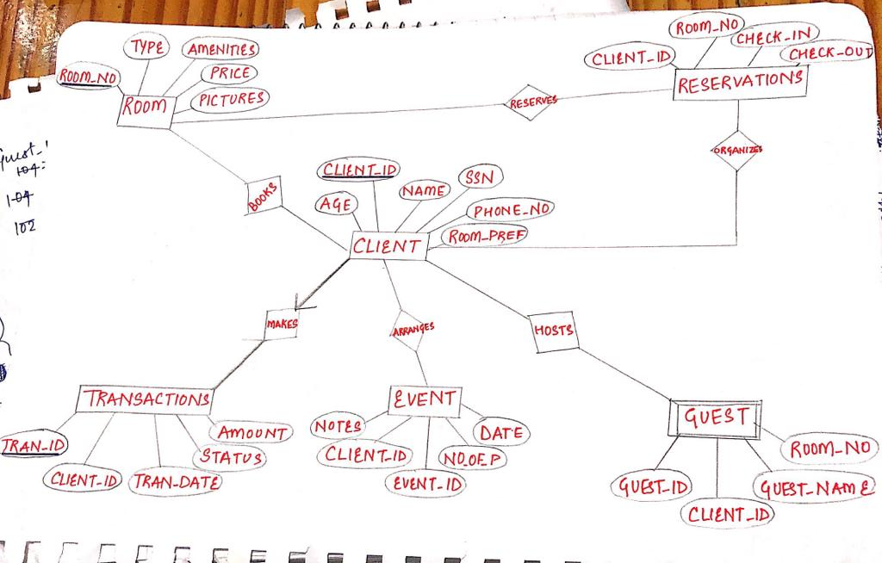

**Relational Algebra Query**

Question: Find the customer (or customers) who paid the highest room rate in 2017 and is

also related to at least one more non-primary customer.

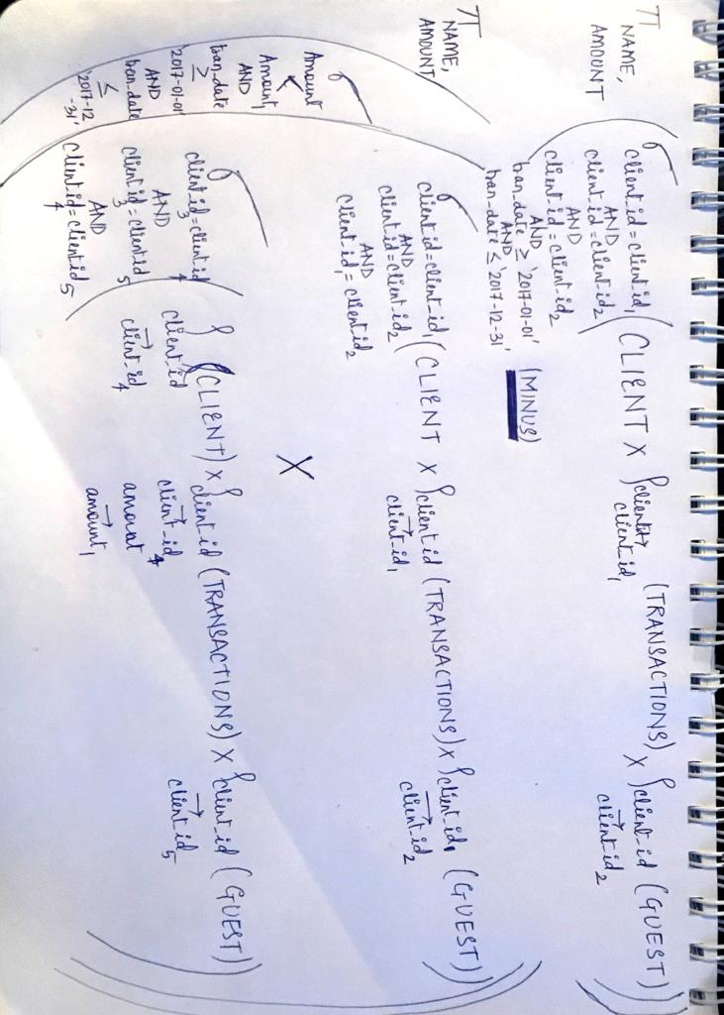

**SQL Query**

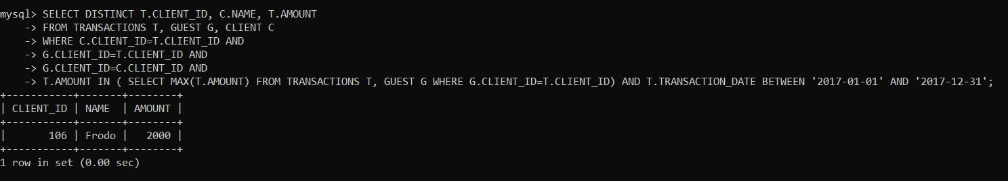

The data in table (i.e. the o/p of ‘Select * from xyz table’) is displayed in the file attached that contains all the table description and SQL entries and other codes.